**Project Design Phase-II**

**Data Flow Diagram & User Stories**

|  |  |
| --- | --- |
| Date | 08 May 2023 |
| Team ID | NM2023TMID11499 |
| Project Name | Dissecting the Digital Landscape : A Comprehensive Analysis of Social Media |

**Data Flow Diagrams:**

A Data Flow Diagram (DFD) is a traditional visual representation of the information flows within a system. A neat and clear DFD can depict the right amount of the system requirement graphically. It shows how data enters and leaves the system, what changes the information, and where data is stored.

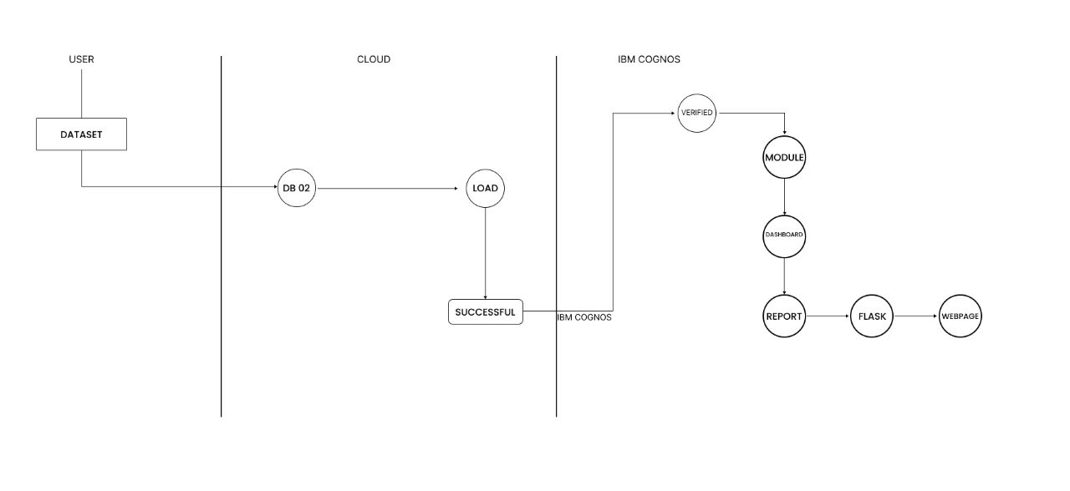

**User Stories**

Use the below template to list all the user stories for the product.

| **User Type** | **Functional Requirement (Epic)** | **User Story Number** | **User Story / Task** | **Acceptance criteria** | **Priority** | **Team Member** |
| --- | --- | --- | --- | --- | --- | --- |
| End User | Data Collection | USN-1 | As an end user, I want to collect literacy data | - The system should retrieve accurate and up-to-date data | High | GOKUL |
| Data Analyst | Data Processing | USN-2 | As a data analyst, I want to clean and preprocess data | - The system should remove inconsistencies and errors | Medium | PAUL |
| Data Analyst | Data Analysis | USN-3 | As a data analyst, I want to analyze literacy trends | - The system should identify patterns and trends in literacy rates | High | PAUL |
| End User | Visualization | USN-4 | As an end user, I want to view visualizations of literacy data | - The system should present visual representations of literacy rates | High | DHANAPAL |
| Data Analyst | Reporting | USN-5 | As a data analyst, I want to generate reports on literacy rates | - The system should generate comprehensive reports with insights | Medium | PAUL |
| Security Specialist | Security | USN-6 | As a security specialist, I want to implement data security measures | - The system should ensure confidentiality and integrity of literacy data | High | JOHN |
| System Administrator | Scalability | USN-7 | As a system administrator, I want to ensure the system can handle increasing data | - The system should be designed to handle growing volumes of literacy data | High | JUEL |
| UI/UX Designer | Usability | USN-8 | As a UI/UX designer, I want to create a user-friendly interface | - The system should have an intuitive and easy-to-use interface | High | KARTHI |
| Data Engineer | Performance | USN-9 | As a data engineer, I want to optimize data processing | - The system should efficiently process and analyze data | Medium | DHARANI |